« La Ferme d’Arnelle »

Rue de Sart-Risbart 40, 1325 LONGUEVILLE (CHAUMONT-GISTOUX)

https://www.google.com/maps/@50.694827,4.743776,16z?hl=fr

- Prendre E411 à Auderghem et quitter Avenue de l'Université, Boulevard du Triomphe/N206 et Avenue de Beaulieu/N210, 7 min (2,9 km)
- Suivre E411 en direction de Chemin du Pont Valériane à Walhain.
- Prendre la sortie 10-Walhain et quitter E411, 18 min (31,1 km)
- Suivre Chemin du Pont Valériane, Rue Sainte-Wivine et Rue de Longueville en direction de Rue de Sart Risbart à Chaumont-Gistoux

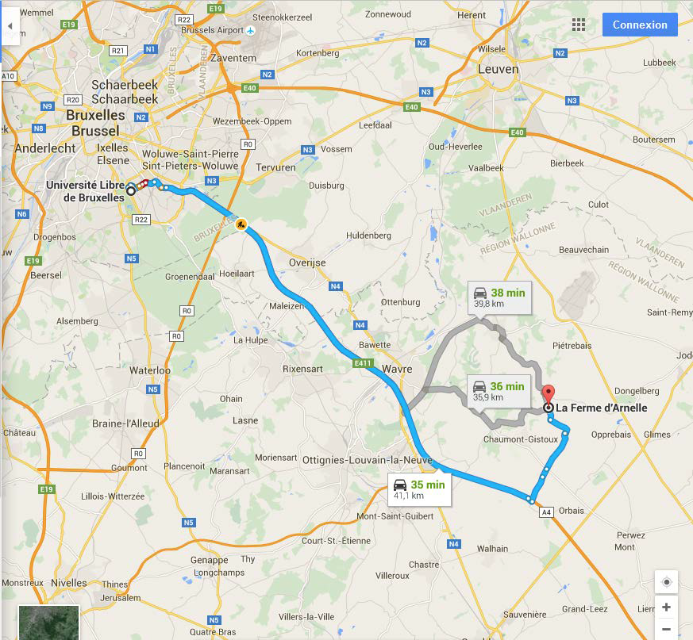

5th UNI
General Meeting

Friday April 20th, 2018

Program:

13:30 Arrivals & Welcome
13:50 Introduction: Axel Cleeremans

14:00 Keynote Lecture: Christian Luscher (Université de Genève)
A circuit model for drug addiction: from molecular mechanisms to therapeutic options.

15:00 Mikhaïl Kissine (ACTE, ULB)
Learning language from the inside out: Linguistics and Autism.

15:30 Charline Urbain (CRCN & LCFC)
MEG applied to the understanding of learning and executive functions in paediatrics.

16:00 Coffee break

16:45 Tom Lenaerts (IB2)
Towards the prediction of oligogenic causes via machine learning in neurodevelopmental diseases.

17:15 UNI Ph.D. student : Rebecca Sifuentes (CRCN/UR2NF)
The role of REM sleep in memory reactivation and consolidation processes.

17:45 UNI PhD student : Adria Razzauti Sanfeliu (Laurent group)
Protein aggregation in glial cells and its effects on neuronal functions in C. elegans.

18:00 Cocktail
19:00 Dinner, then Party on!
Location:

« La Ferme d’Arnelle »
Rue de Sart-Risbart 40,
1325 LONGUEVILLE (CHAUMONT-GISTOUX)

- By UNIBUS: Take the bus to go to the meeting and to come back.

Departure points:

12:00 Erasme Campus
rue Meylemeersch (in front of the student car park)

12:30 Solbosch Campus, Av. P. Héger, in front of P.U.B.

Return:

22:30 - Departure from Longueville
23:10 - Stop metro Delta
23:15 - Stop Solbosch Campus
23:45 - Stop Erasme Campus

- By car: Directions appear on the back of the flyer

Contact:

Angélique Bernacki (CRCN / Solbosch)
M: abernack@ulb.ac.be
T: 026502631

